**Sequence Diagram:**

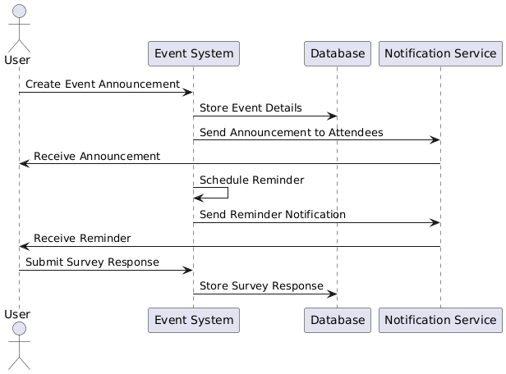

**State Diagram**

**Class Diagram**

**ERD**

**Functional Requirements**

1. The system shall allow users to create event announcements.
2. The system shall store event details in the database.
3. The system shall send announcements to attendees via a notification service.
4. The system shall schedule and send reminders for upcoming events.
5. The system shall allow users to submit survey responses.
6. The system shall store survey responses in the database.

**Non-Functional Requirements**

1. The system shall process announcements and reminders within 5 seconds.
2. The system shall ensure data consistency and integrity.
3. The system shall support at least 10,000 concurrent users.
4. The system shall use encryption for storing user data.
5. The system shall have a 99.9% uptime availability.
6. The system shall be accessible via both web and mobile platforms.